https://www.linkedin.com/pulse/hobby-project-setting-up-static-website-using-amazon-kuldip-medhe

How to generate AWS Certificate Manager (ACM) to generate a certificate

1. Sign into AWS: Go to the AWS Management Console (https://console.aws.amazon.com) and sign into your AWS account.
2. Open the ACM service: Once you're signed in, search for "Certificate Manager" in the search bar or navigate to the "Security, Identity & Compliance" section and click on "Certificate Manager" to open the ACM service.
3. Request a certificate: In the ACM dashboard, click on the "Request a certificate" button.

1. Choose the certificate type: ACM supports multiple types of certificates. Select the appropriate option based on your requirements. For example, you can choose "Request a public certificate" to generate a certificate for use with web servers or load balancers.

1. Add domain names: In the "Add domain names" section, enter the domain names for which you want to generate the certificate. You can specify multiple domain names or subdomains using a comma-separated list.
2. Select validation method: Choose how you want to validate ownership of the domain. ACM provides several methods, including DNS validation and email validation. Select the method that suits your needs.
3. DNS Validation: ACM provides instructions to add a specific DNS record to your domain's DNS configuration. Follow the instructions and add the required record to your DNS settings.

1. Email Validation: ACM sends an email to the domain owner's email address associated with the domain registration. Follow the instructions in the email to complete the validation process.
2. Add tags (optional): You can optionally add tags to your certificate for easier management and identification.
3. Review and confirm: Review the details you've entered, ensuring that the domain names and validation methods are correct. Click on the "Confirm and request" button to submit the certificate request.
4. Complete the validation process: Depending on the validation method you selected, complete the necessary steps to validate ownership of the domain. For DNS validation, wait for the DNS changes to propagate. For email validation, follow the instructions in the email to confirm ownership.
5. Certificate issuance: Once the validation process is complete, ACM will issue the certificate for the specified domain names. You can view and manage your certificates in the ACM dashboard.

Use the certificate: After the certificate is issued, you can use it with various AWS services such as Amazon CloudFront, Elastic Load Balancing, or Amazon API Gateway, depending on your specific use case. The process for applying for the certificate varies depending on the service, so consult the respective documentation for instructions.

Route 53-

Select hosted zone > create record > simple routing > define simple record.

Copy record name from Certificate manager > CNAME & CNAME VALUE >

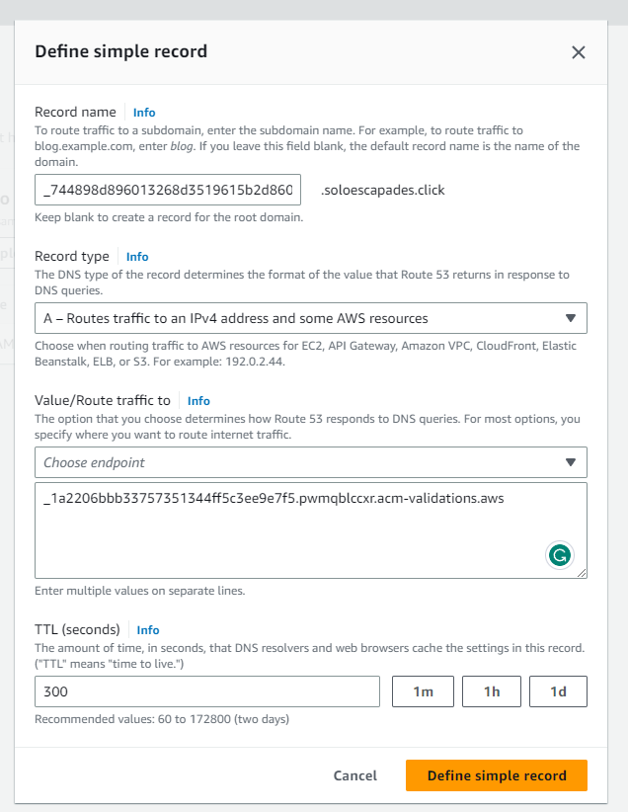

How to create CloudFront distribution with HTTPS support

1. Sign into AWS: Go to the AWS Management Console (https://console.aws.amazon.com) and sign into your AWS account.
2. Open the CloudFront service: Once you're signed in, search for "CloudFront" in the search bar or navigate to the "Networking & Content Delivery" section and click on "CloudFront" to open the CloudFront service.

1. Create a new distribution: In the CloudFront dashboard, click on the "Create Distribution" button.

1. Configure the distribution settings:

* Origin Settings: Specify the origin of your content. This can be an S3 bucket, an EC2 instance, or any other custom origin. Configure the relevant settings based on your use case.
* Default Cache Behavior Settings: Configure caching behavior, headers, and query string parameters. Enable or disable features as needed.
* Distribution Settings: Set the distribution settings, including the domain name, SSL certificate, and supported protocols.
* Alternate Domain Names (CNAMEs): Add any custom domain names (e.g., www.example.com) that you want to associate with your distribution – add item > *soloescapades.click*
* SSL Certificate: Choose "Custom SSL Certificate" and select an existing SSL certificate from AWS Certificate Manager (ACM) or upload a custom SSL certificate if you have one.



1. Create the distribution: Review your settings, make any necessary changes, and click on the "Create Distribution" button to create the CloudFront distribution.
2. Wait for distribution deployment: CloudFront will take some time to deploy your distribution across its edge locations. The status of your distribution will change from "InProgress" to "Deployed" once the deployment is complete.

1. Update DNS settings: If you're using a custom domain name, update your DNS settings to point the domain to the CloudFront distribution. You can retrieve the CloudFront domain name from the distribution details page.
2. Go to Route 53 > create another record set > click on hosted zones > create record.

Simple > define simple record > alias to CloudFront distribution > create records.

1. Test the HTTPS access: After the DNS changes propagate, you should be able to access your content securely over HTTPS using the CloudFront domain or your custom domain name.

By following these steps, you can create a CloudFront distribution with HTTPS support, ensuring that your content is delivered securely to your users.

